Test Script: |  |  |  |  |  |  |  | Created by: | Esteban Perez |  | Created Date: |  | 24/07/2025
Initiative Name: |  |  |  | AOP- ATH Móvil - Reporting Center 2025 |  |  |  |  |  |  | Initiative ID: |  | ET-2025-05163
Description: |  |  |  | Execute AWS Pipeline
QSR: |  |  |  | Request ID / Incident ID |  |  | Package ID: |  | Application ID: | Testing Start Date: |  |  | Test Type:
QSR 2666059 |  |  |  | ESR 2466741 |  |  | ATHM-CRT-ANL-WebPortal -> d6bb6bf9  ATHM-CRT-ANL-DataFlow -> 5f77d690  ATHM-CRT-ANL-GENERAL-REPORTS-DEPLOYMENT-> 9aa5f0d8  ATHM-CRT-ANL-GENERAL-REPORTS-SERVICE -> 3e8afcac |  | ATHRC | 24/07/2025 |  |  | Functional
No. |  | Business Function/Requirement |  |  | Actions/Setup |  |  |  | Expected Results |  | Actual Results | Status
 |  | Execute TestScript a ATHM-CRT-ANL-WebPortal |  |  | 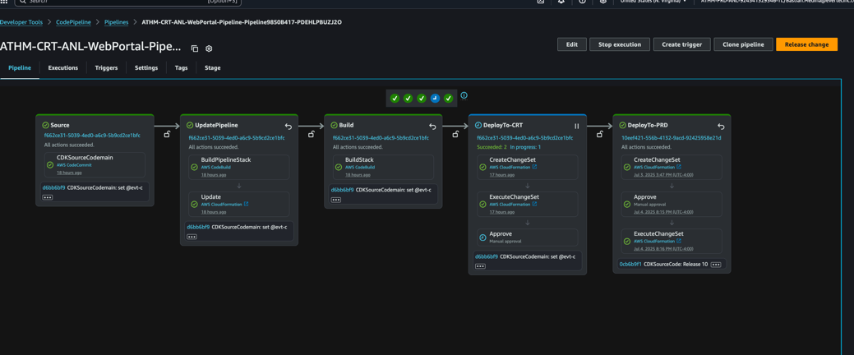 |  |  |  | Script executes as expected. |  | As Expected | Pass
 |  | Execute TestScript a ATHM-CRT-ANL-DataFlow |  |  | 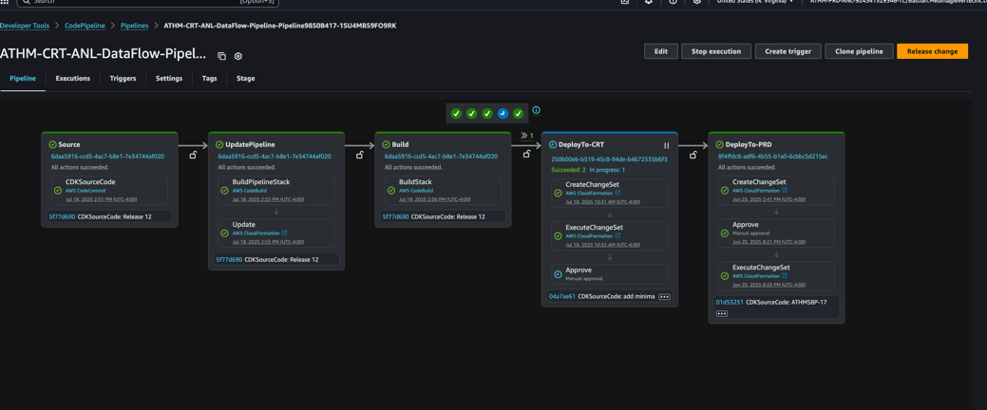 |  |  |  | Script executes as expected. |  | As Expected | Pass
 |  | Execute TestScript a ATHM-CRT-ANL-GENERAL-REPORTS-DEPLOYMENT |  |  | 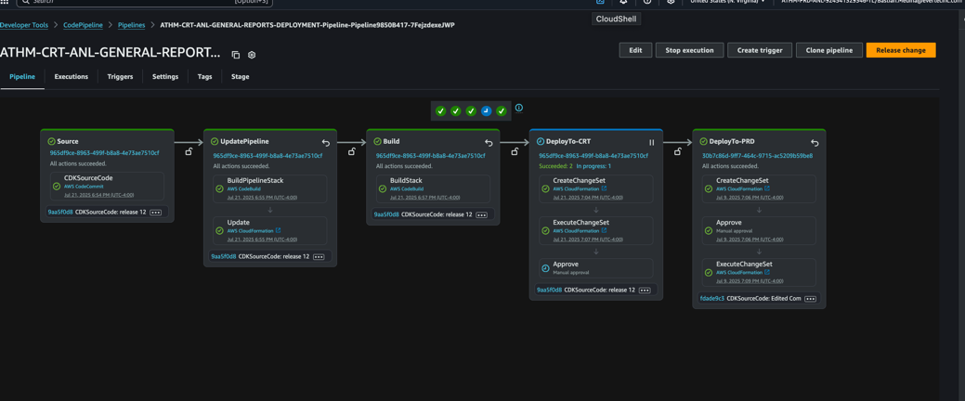 |  |  |  | Script executes as expected. |  | As Expected | Pass |  |  | ATHM-CRT-ANL-REPORTING-API-SERVICE | 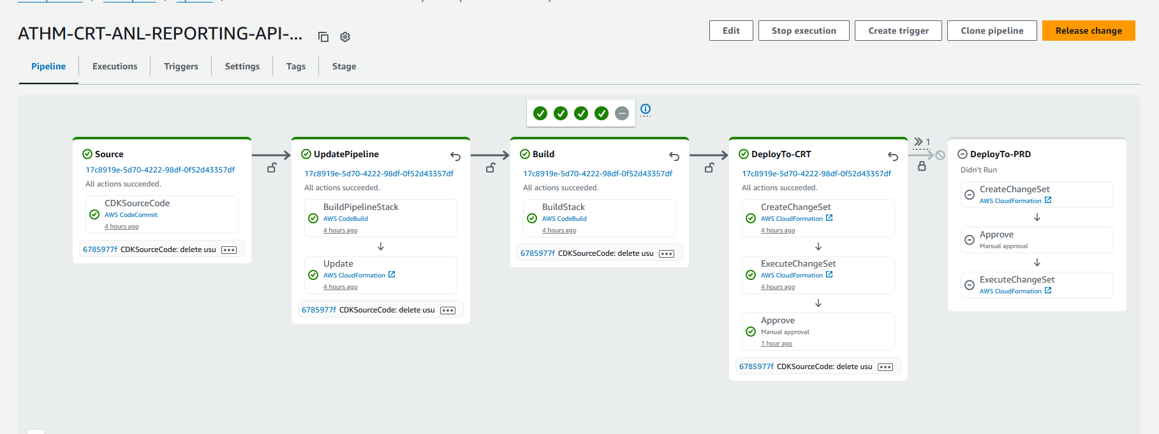 | Script executes as expected. | As Expected | Pass
 |  | Execute TestScript a ATHM-CRT-ANL-GENERAL-REPORTS-SERVICE |  |  | 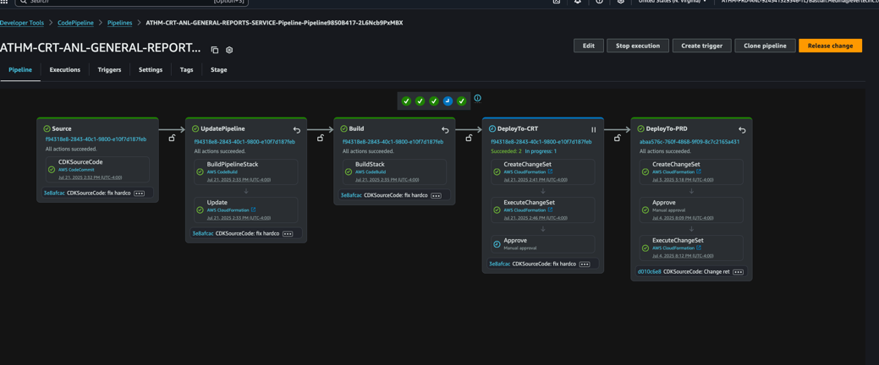 |  |  |  | Script executes as expected. |  | As Expected | Pass
The tests were performed, and we have examined the results contained in this test script. The changes comply with our requirements therefore can be implemented in the production environment. (Tester and end user approver can be completed electronically).

End User Tester | End User Approval
Esteban Perez | Digmarie Feliciano

For Printed version only: Click here to insert the Justification and Signatures fields.

